Check the .net version 4.6 installed or not. If not installed please install the.net version from internet

Click on the application pool and create or use existing application created for asp.net 4.0.

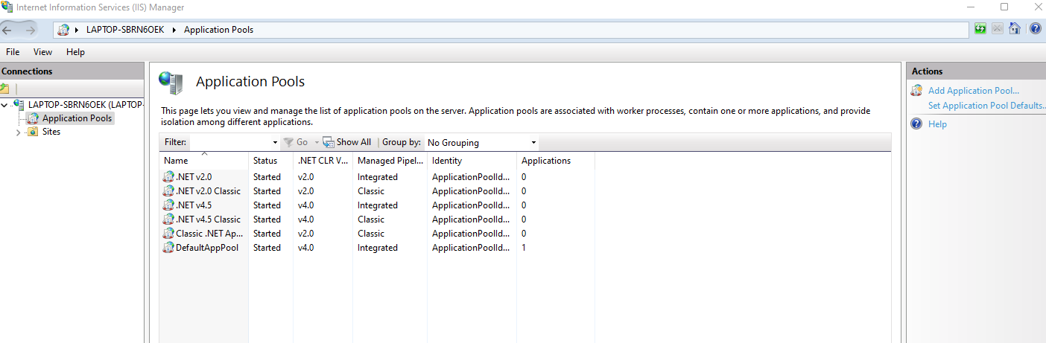

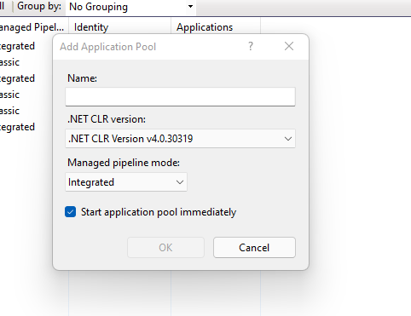

Create website by right click on site option from left side menu.

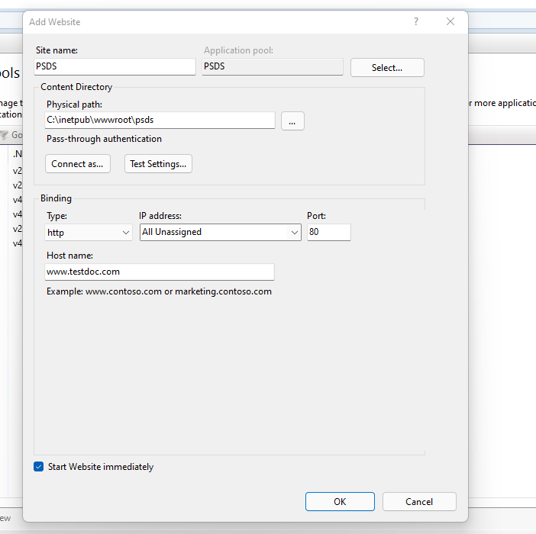

Create virtual directory with domain name

Map the Physical file path to the created virtual directory

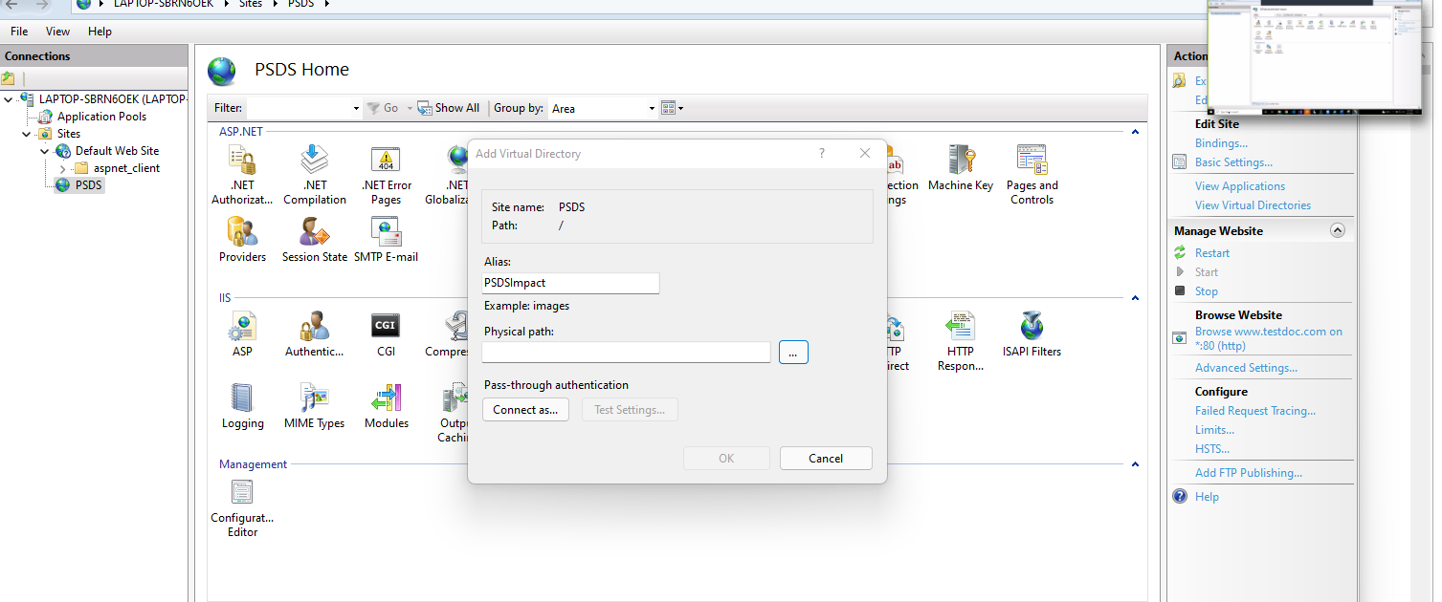

If the site needs to be deployed on the HTTPS mode, install the SSL certificate on the IIS server in the virtual directory

After mapping the folder to virtual directory change the binding of application from write side menu, and define port and domain mapping for the virtual directory.

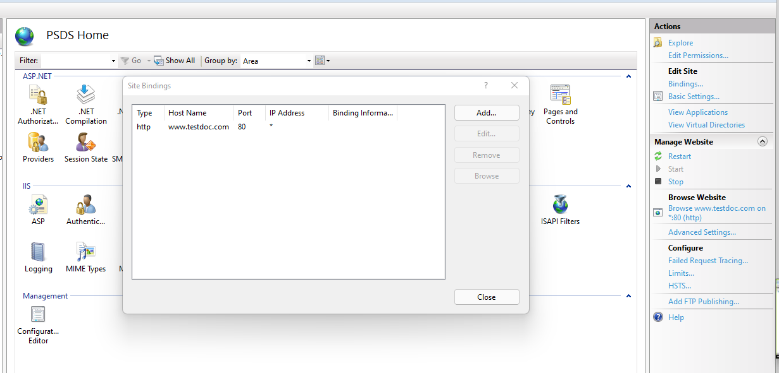

Map the particular application to the application pool

If website need to be run on both http and https configure binding for both http and https. Make sure the port used does not duplicate to already installed application

While define the https binding the option appear for map the ssl certificate which is laredy installed on the iis.

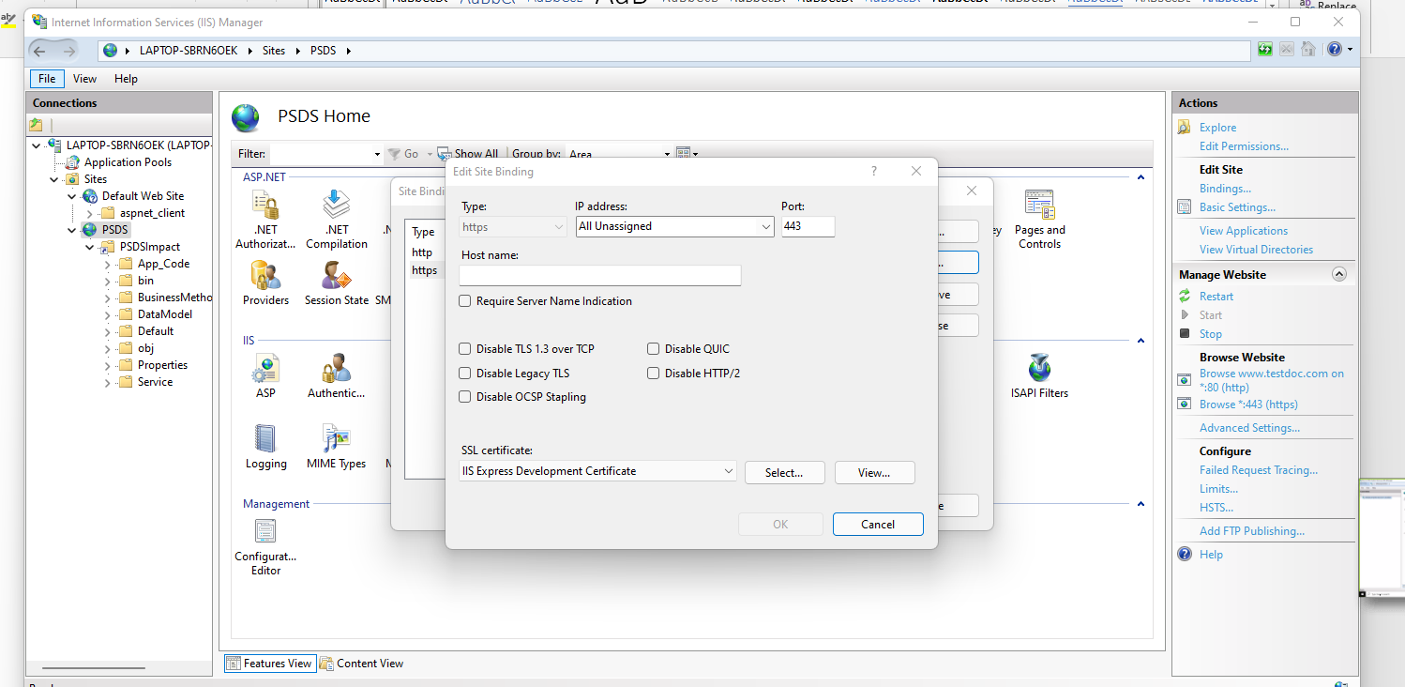

Map the SSL certificate to the virtual directory binding

Once above steps are done open inetpub\wwwroot foler and open web.config file.

Search connection string and modify the connection string to point the step1 created DB.

For that DB server, username, password and initial catalog needs to be changed.